Virtual Field Trip to Central Texas

Physical Geology - Spring 2025

Name:

myUH ID number:

Professor’s Name:

Class Time:

# Academic Honesty (Acknowledgement Required)

The Virtual Field Trip to Central Texas is to be completed by yourself; you should not work with a partner or group. Do not search for answers on the internet because 1) it is cheating; 2) answers that are posted are incorrect, and we’ll know where you got them from, and; 3) the questions change every semester. Be careful if you watch the videos with closed captioning because the spelling of geologic terms is often incorrect or misinterpreted by the captioning software, so you may end up with a wrong answer. If you are unfamiliar with a word or geologic concept, it is okay to look it up online to find the correct spelling and definition. If you find yourself needing help, physical geology teaching assistants staff the [Geoscience Learning Center](https://uh.edu/nsm/earth-atmospheric/undergraduate/learning-center/index).

By submitting this work, I, Type Your Name Here attest that I have not violated the UH Academic Honesty code. I completed this assignment by myself and did not copy any portion of my answers from another student, website, or any other source, including AI.

If you submit this material to an online learning platform such as Chegg, Course Hero, or any other education technology website, you violate the UH academic honesty policy and the Creative Commons license

# Instructions

The virtual field trip to Central TX is a Google Earth tour that will require you to watch videos of our field trip stops, answer questions, and make interpretations on snapshots of GigaPan images (very large, high quality).

**To receive credit, all answers need to be complete sentences** and typed in the supplied boxes. Your responses will appear in a red-colored font; do not change this. Any answers not written in complete sentences will be marked as incorrect and will not receive credit.

You’ll need to take snapshots of high-resolution images from the field trip stops. Follow the directions below according to your operating system. Paste the snapshot into PowerPoint, Paint, or a similar program to make annotations and highlight items of geologic interest. Common annotations include drawing circles and lines.

[PC Directions](https://support.microsoft.com/en-us/help/13776/windows-10-use-snipping-tool-to-capture-screenshots) for taking snapshots (Windows 10, 11)

[Mac Directions](https://support.apple.com/en-us/HT201361) for taking snapshots (MacOS)

## Accessing the Trip

This virtual field trip was built using Google Earth. [Click here to access the trip](https://earth.google.com/earth/rpc/cc/drive?state=%7B%22ids%22%3A%5B%2214xN2ZEHdNStkryosrg35_Wv46ZRC-GgO%22%5D%2C%22action%22%3A%22open%22%2C%22userId%22%3A%22111044525520816793780%22%7D&usp=sharing). The first thing you will see is an overview of Texas and the field trip stops. In the menu on the left side, click on “Present” to begin the tour. At each location, a box will appear on the right side of the screen with information about each stop, the videos you need to watch, and links to the GigaPan images. Use the menu on the bottom left to move between stops.

## Assignment Submission

All virtual field trips are due by Sunday, April 27. Save your completed Word document as “yourlastname_firstname_CentralTXVFT”. Failure to use this naming convention may result in you not receiving credit. The file size must be less than 100 MB. If you need to [reduce your file size](https://support.microsoft.com/en-us/office/reduce-the-file-size-of-your-word-documents-6c5a1186-6353-453d-bb22-e9322c2cfbab), make sure images/annotations are still legible. Submit your completed document using the following [form](https://forms.office.com/r/ev94un4pJe), you must be logged into your @cougarnet.uh.edu Microsoft account. Only Microsoft Word and PDF formats are accepted.

**Due Date:** Sunday, April 27

**Submission link:** <https://forms.office.com/r/ev94un4pJe> (make a separate submission for each VFT you complete)

Teaching Assistants will begin grading submissions after the deadline. After your work is graded, you will receive a confirmation email from a TA. Submissions are graded as pass/fail. If your assignment requires resubmission because of too many incorrect questions, missing answers, or incomplete sentences, you will have 48 hours to do so.

# Stop 1: Observations for the Edwards Formation

Head to Stop 1 of the [virtual field trip](https://earth.google.com/earth/rpc/cc/drive?state=%7B%22ids%22%3A%5B%2214xN2ZEHdNStkryosrg35_Wv46ZRC-GgO%22%5D%2C%22action%22%3A%22open%22%2C%22userId%22%3A%22111044525520816793780%22%7D&usp=sharing). Watch the video at Bee Cave Road and view the GigaPan image.

## Video Questions for Stop 1

1. Describe how and why sediments change in age as you go from Houston to Austin.

1. Describe the Edwards limestone, including information such as minerals present, texture, grain size, color, weathering, size of bedding, etc.

1. Some say the Edwards limestone is not a pure limestone. What makes it a dirty limestone?

1. What was the depositional environment for the Edwards limestone??

1. Describe the Cretaceous interior seaway.

1. There is a small fault at this outcrop that is part of the Balcones fault system.
   1. What type of fault is this?

* 1. What are the linear features on the fault surface, how did they form, and what do they tell us?

1. The Edwards aquifer is an underground layer of porous rock with water and supplies water to over 2 million people. This stop is in the [recharge zone](https://www.encyclopedia.com/environment/encyclopedias-almanacs-transcripts-and-maps/recharge-zone) of the Edwards aquifer. Groundwater flows to a [discharge zone](https://www.lawinsider.com/dictionary/discharge-zone) which includes natural springs.
   1. In your own words, describe what a recharge zone is.

* 1. What are the two main ways that water gets into the aquifer?

* 1. What is the evidence in this outcrop for how water gets to the discharge zone?

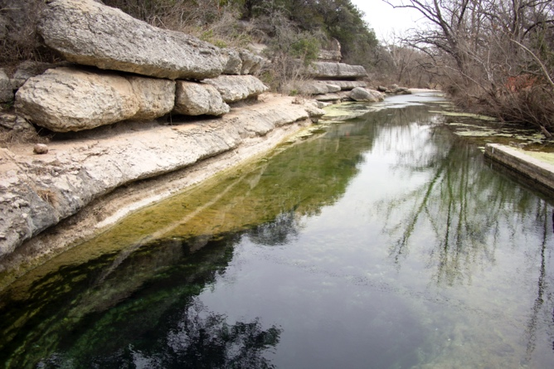

1. The Texas Hill country has 93 natural springs such as Jacob’s Well near Wimberley TX (shown above). This natural spring is the headwaters of Cypress Creek. The US Geological Survey monitors its discharge. Go to <https://waterdata.usgs.gov/monitoring-location/08170990/#dataTypeId=continuous-00060-0&period=P365D&showMedian=false>
   1. Click on the button for discharge. What is the discharge at Jacob’s Well today?

* 1. Is this high or low compared to the past year?

* 1. Why do you think the discharge rate changes?

1. Some of these springs produce drinking water for people and livestock and others are used as swimming holes. These springs are fed by the Edwards aquifer. Look at the figure below which plots all the springs in the Hill Country in 1975 and 2024. This includes whether or not the springs are flowing (green dots), intermittent (yellow dots), or dry red triangles). In 1964, three historic springs were inundated by the damming of the Guadalupe River, forming Canyon Lake (blue dots).

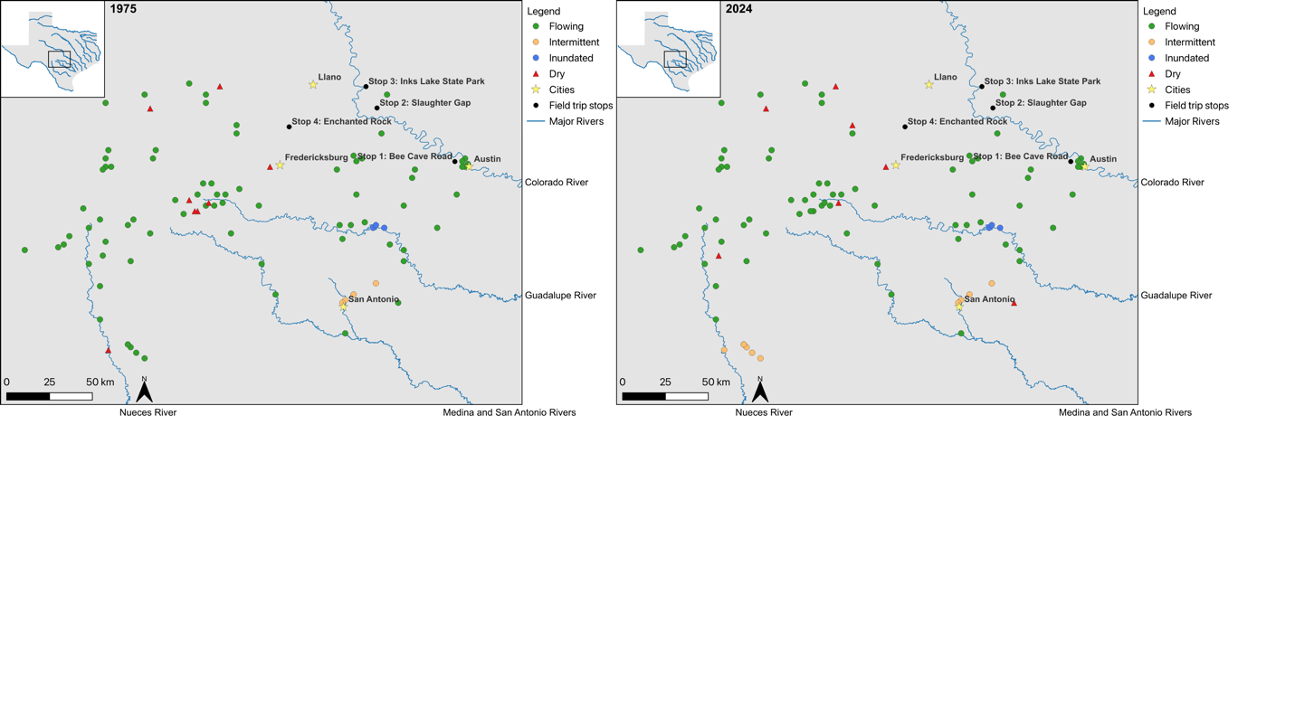

* 1. Describe differences and similarities between these two maps. For example, compare the number and location of various types of springs.

* 1. Do you think the differences in this distribution is due to long-term climate change, changes in the aquifer, or water use by either farming or population changes. Or perhaps there was a change in water use policies between 1975 and 2024?

## GigaPan Questions for Stop 1

1. Take a new screenshot of the Edwards Formation and trace three contacts between sedimentary beds.

**Paste your screenshot with annotations here**

1. Are all the beds in the Edwards formation the same thickness? Describe what you see. You may want to zoom out and relook at the entire GigaPan image.

1. The Edwards formation has been affected by chemical weathering, both at the surface and underground. Search the GigaPan image for any evidence that chemical weathering affected this outcrop.
   1. What type of chemical weathering is prominent?

* 1. Include a screenshot with annotations that support your answer.

**Paste your screenshot with annotations here**

* 1. Do these chemical weathering features enhance or reduce the ability of the Edwards Formation to be an aquifer?

# Stop 2: Observations for Slaughter Gap

This field trip stop has two different rock types: an igneous rock that students are standing on and a sedimentary rock behind them.

## Video Questions for Stop 2

1. Describe the igneous rock the students are standing on. Include observations such as color, minerals present, texture, grain size, name of the rock, and its age.

1. What was its cooling rate? Please explain your answer.

1. Describe the sedimentary rock located behind the students. Include information such as the type of sedimentary rock, grain size, grain shape, minerals present, color, bedding thickness, age, and any other features.

1. What type of unconformity exists between the rock students are standing on and the rock behind them? How long was the time gap between these two units?

## GigaPan Questions for Stop 2

The first image was taken at the location where the students were standing, shown at the red arrow’s tip on the topographic map of Slaughter Gap (Figure 1). The second image is the view across the gap from the first location, as shown by the red line on the topographic map. The base of the second GigaPan image is parallel to the red line shown below.

Figure 1 - Topographic map of the Slaughter Gap region provided by Dr. Leon Long, University of Texas at Austin

1. On the first GigaPan image, locate the contact between the igneous rock and the sedimentary rock. You may have to zoom in and move around the image to look at the rock textures to help.
   1. Is the contact flat or steep?

* 1. Take a snapshot and draw a line that shows the contact between these two rocks.

**Paste your screenshot with annotations here**

1. Locate this same contact on the second GigaPan image from this stop. You can zoom in to see the rock types within the trees and look for layered rock above the break in slope. Some of these are large boulders that have fallen down the cliff. Take a snapshot and draw a line that shows the contact between the two rock types. The angle of the contact relative to the Earth’s surface should be similar on both sides of Slaughter Gap.

**Paste your screenshot with annotations here**

# Stop 3: Observations for Inks Lake State Park

This stop has two different rock types as well, metamorphic and igneous. The students are standing on one type, and the other is across the stream in the GigaPan images.

## Video Questions for Stop 3

1. Describe the metamorphic rock that students are standing on. Include observations on its color, grain size, minerals, age, and texture (terms such as granoblastic, foliated, or layered).

1. Based on the minerals present, what is the metamorphic grade? Using this, what was the temperature and pressure of metamorphism?

1. Describe the cross-cutting relationships between the igneous and metamorphic rocks and which rock came first.

1. What was the tectonic environment of this region?

## GigaPan Questions for Stop 3

1. In the first image, locate a dike, take a snapshot, and then draw a polygon around it.

**Paste your screenshot with annotations here**

1. In the first image, locate a sill, take a snapshot, and then draw a polygon around it.

**Paste your screenshot with annotations here**

1. In the second GigaPan image, locate a fold, take a snapshot, and draw a box around it.

**Paste your screenshot with annotations here**

# Stop 4: Observations for Enchanted Rock

Enchanted Rock State Natural Area has two exfoliation domes formed by erosion of the Grenville age Town Mountain granite (about 1.1 billion years old), similar to what you heard about at Slaughter Gap. See [this video](https://youtu.be/rT-iPv9Q1fI?t=296) for an explanation of exfoliation domes and [watch exfoliation in action](https://geotripper.blogspot.com/2014/08/exfoliation-in-action-in-twain-harte.html).

The Town Mountain Granite intruded into the Packsaddle Schist (the schist is not visible in the GigaPan image). The two granite domes are part of the second-largest batholith in the Llano Uplift. The tallest dome is 425 ft above ground level.

There are no video questions from our Enchanted Rock stop, only observations made from images.

## GigaPan Questions for Stop 4

1. Locate the first GigaPan image for this stop.
   1. Take a screenshot and draw a polygon around the granite block on the dome to show the exfoliation process.

**Paste your screenshot with annotations here**

* 1. Do you think that more of these blocks will form in the future? Be sure to explain your answer.

* 1. Which of the following do you think is most likely to happen? Will the granite blocks 1) undergo further mechanical weathering, break into smaller pieces, slide down the side of the dome, and be added to the granite rubble pile at the bottom or 2) will the granite blocks be chemically eroded by rain? Be sure to explain your answer.

1. Locate the second GigaPan image for this stop.
   1. Take a snapshot and use a pen tool to trace the path of a black stripe running down the slope of the dome.

**Paste your screenshot with annotations here**

* 1. What type of weathering causes these stripes?

## Assignment Submission

All virtual field trips are due by Sunday, November 24. Save your completed Word document as “yourlastname_firstname_CentralTXVFT”. Failure to use this naming convention may result in you not receiving credit. The file size must be less than 10 MB. If you need to [reduce your file size](https://support.microsoft.com/en-us/office/reduce-the-file-size-of-your-word-documents-6c5a1186-6353-453d-bb22-e9322c2cfbab), make sure images/annotations are still legible. Submit your completed document using the following [form](https://forms.office.com/r/ev94un4pJe), you must be logged into your @cougarnet.uh.edu Microsoft account. Only Microsoft Word and PDF formats are accepted.

**Due Date:** Sunday, April 27

**Submission link:** <https://forms.office.com/r/ev94un4pJe> (make a separate submission for each VFT you complete)

Teaching Assistants will begin grading submissions after the deadline. After your work is graded, you will receive a confirmation email from a TA. Submissions are graded as pass/fail. If your assignment requires resubmission because of too many incorrect questions, missing answers, or incomplete sentences, you will have 48 hours to do so.