LELAND FELLOWS provides University of Houston students the opportunity to learn and serve as government interns in Washington, D.C. during the spring semester.  Leland Fellows work full-time from January through the first of May. Selected students will be provided a monthly stipend, round-trip airfare, and paid housing during their internship in Washington, D.C.  View the Leland Fellows webpage for more information. | 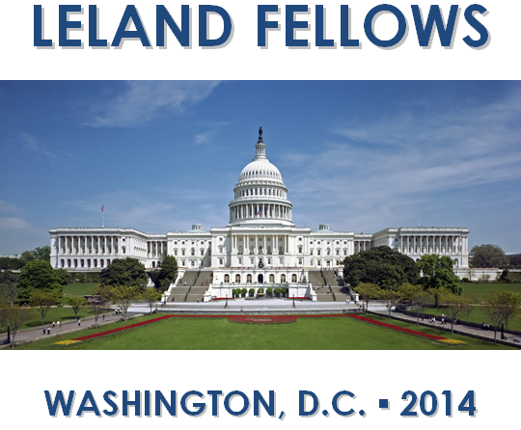
Eligibility Requirements
- Must be a junior or senior at the University of Houston during the semester of application.
- Students from any major are encouraged to apply.
- Transfer students must have completed a minimum of 24 hours at UH.
- Students graduating in fall 2025 are eligible to apply but must re-enroll as a post-baccalaureate.
- Must be in good academic standing with a minimum GPA of 3.0 on a 4.0 scale.

Ideal candidates will possess
- Outstanding academic achievement
- Strong writing ability
- Excellent interpersonal skills
- Demonstrated dedication to public service through volunteerism in school and/or community activities
- Internship experience, through the Hobby School’s Civic Houston Internship Program (CHIP)
- Personal interviews, academic achievement, writing ability, community and school activities, previous internship and/or professional experience, and financial hardship are all considered during the selection process

Program Requirements
Leland Fellows are expected to commit a minimum of 40 hours per week to their internship. They will also be required to participate in seminars, weekly check-ins with the Program Director and complete various academic assignments, enabling them to earn 3-12 academic credit hours. Before the initial stipend is issued, Fellows must be enrolled for the appropriate hours/classes through the UH Department of Political Science or Public Policy, and proof of enrollment is required. Fellows must not be concurrently enrolled in any other courses while completing the internship.

Application Packet
Applications must be typed. Incomplete or late applications will not be accepted.
□ Typed application form
□ Resume (view acceptable resume format here on pg. 18)
□ Personal statement
□ Writing sample (Congressional office requirement)
□ Official academic transcripts (electronic delivery only. See more information here)
□ Proof of financial aid status (screenshot of the current year in myUH Self Service)
□ Two letters of recommendation (up to 3 will be accepted – must be submitted by your recommenders)

Submit your complete application to:

Jessica Ruland O’Connor via email at: jlruland@cougarnet.uh.edu.

Application Deadline: Monday, October 6, 2025

LELAND FELLOWS

Spring 2026 APPLICATION

Personal information

Name:

Permanent Address:

Current Address:

Email Address:

Telephone: Alternate Telephone:

Age: People Soft Number:

Major(s): Minor(s):

Cumulative GPA: Classification:

Projected date of graduation: First generation: Y | N

EDUCATION, EXPERIENCE & SKILLS

What courses have you completed that are relevant to a congressional internship?

List experience in political campaigns, governmental internships, and/or community service.

List any technical skills that you have which may be beneficial to a legislative office including all software proficiencies.

List and describe any leadership roles you have held on campus, with community organizations or in employment.

Based on your permanent address, who currently represents you in the U.S. House of Representatives?

REFERENCES

Please list three references: one academic and two professional.

Include name, title, relationship to you, email and phone number.

1.

2.

3.

PERSONAL STATEMENT

Explain why you are applying to Leland Fellows in an essay no more than two pages or 500-750 words (submit as a separate document).
- Discuss your interests in specific public policy issues and community service projects.
- Describe how the internship will benefit your current academic endeavors as well as your long-term career plans.
- Describe how you could be an asset to a congressional office.

CONFIRMATION AND ACKNOWLEDGEMENTS

Please sign your initials beside each statement below.

I understand, that if selected for the program:

___ I am required to be enrolled in the mandatory 3 credit hour POLC/POLS internship course.

___ I am not allowed to be enrolled in any other classes or courses during my time in this program.

___ I will begin my internship the week of January 20 and my last day will be approximately May 4.

___ I will attend a mandatory orientation prior to the internship start date.

___ I understand that if selected, I may need to submit additional documentation such as a writing sample and cover letter for office placement purposes.

The information given above is complete and accurate to the best of my knowledge. I am aware that any misrepresentation will result in the disqualification of my application. I hereby give permission to the members of the Leland Fellows selection committee to review this information for purpose of evaluating my eligibility for a position as a Leland Fellows intern.

Signature Date
APPLICATION DEADLINE: MONDAY, OCTOBER 6, 2025

For more information about the Hobby School of Public Affairs and its activities, go to https://uh.edu/hobby/

The University of Houston provides equal treatment and opportunity to all persons without regard to race, color, national origin, sex, age, disability, veteran status, or sexual orientation except where such distinction is required by law. This statement reflects compliance with Titles VI and VII of the Civil Rights Act of 1964 and Title I of the Educational Amendment of 1972 and all other federal and state regulations.

